Ali Hassaan Mughal 173627 BSCS 6-B

Code:

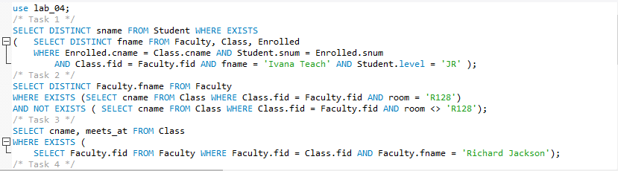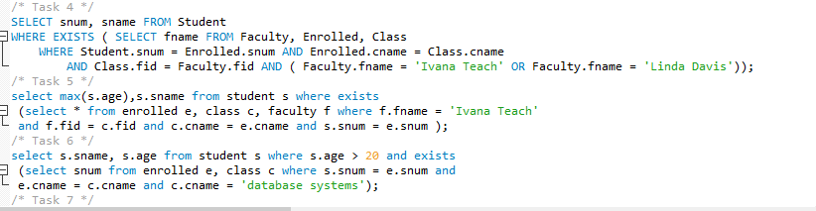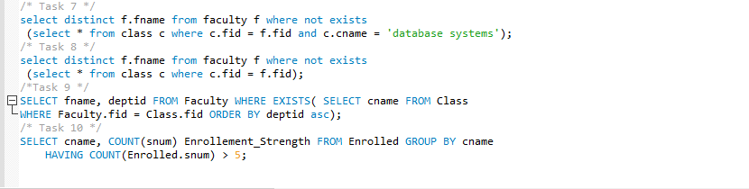

LOGS

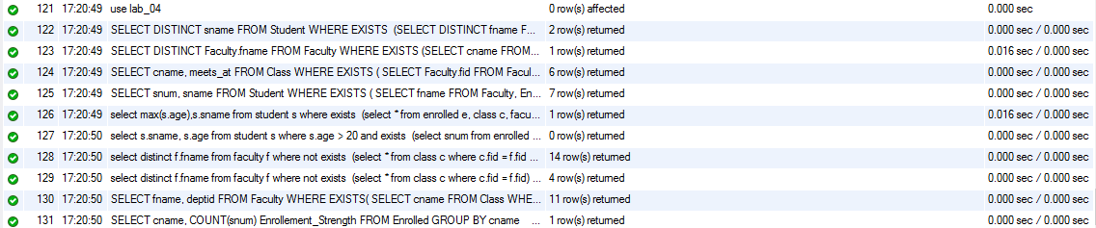

Task 1:



Task 2:



Task 3:

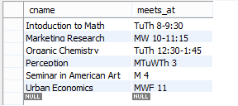

Task 4:

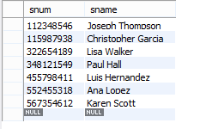

Task 5:



Task 6:



Task 7:

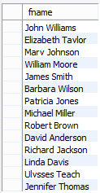

Task 8:

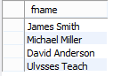

Task 9:

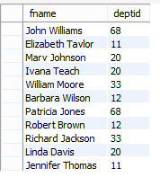

Task 10:

